REACT-01
Objectives

- Define SPA and its benefits
A Single Page Application (SPA) is a type of web application where everything happens on one page. Instead of loading a new page every time you click on something, the content updates dynamically within the same page.
Benefits of SPA:
Fast user Experience, No Page Reloads, Easy to debug.
- Define React and identify its working
React is a JavaScript library developed by Facebook for building modern user interfaces, especially SPAs.It works like example I few have build our app using component and that component use something called JSX which is a combination of both HTML and Javascript.
- Identify the differences between SPA and MPA
SPA: A Single Page Application loads a single HTML page and dynamically updates the content without reloading the entire page, resulting in a faster and smoother user experience
MPA: A Multi Page Application loads a new page from the server every time the user navigates to a different section, which can be slower but is better for SEO.
- Explain Pros & Cons of Single-Page Application
Pros:
Fast and respomsive,Smooth user experience,Easier to build interactive features.
Cons:
Initial loading time takes longer time, Needs good client-side javascript management.
- Explain about React
React is a frontend Javascript library used to build user interfaces, especially single-page applications. It's all about creating reusable component that make it easier to build and manage complex apps.
- Define virtual DOM
The Virtual Dom is like a copy of the real Dom (Document Object Model) kept in memory by React.
- Explain Features of React
It makes rendering faster and more efficient, It combines Javascript and HTML like syntax in one place, Data flows in one direction which helps keep the code predictable.

In this hands-on lab, you will learn how to:
- Set up a react environment
- Use create-react-app
Prerequisites

The following is required to complete this hands-on lab:
- Node.js
- NPM
- Visual Studio Code

Notes

Estimated time to complete this lab: 30 minutes.

Create a new React Application with the name “myfirstreact”, Run the application to print “welcome to the first session of React” as heading of that page.
- To create a new React app, Install Nodejs and Npm from the following link:
https://nodejs.org/en/download/
- Install Create-react-app by running the following command in the command prompt:

- To create a React Application with the name of “myfirstreact”, type the following command:

- Once the App is created, navigate into the folder of myfirstreact by typing the following command:
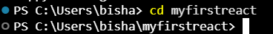
- Open the folder of myfirstreact in Visual Studio Code
- Open the App.js file in Src Folder of myfirstreact
- Remove the current content of “App.js”
- Replacing it with the following:
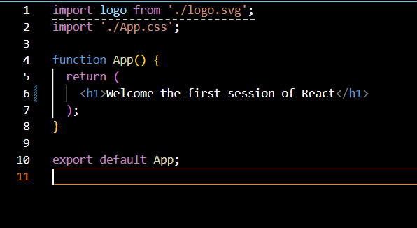

- Run the following command to execute the React application:

- Open a new browser window and type “localhost:3000” in the address bar

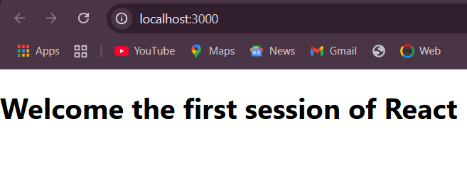

REACT-02
Objectives

- Explain React components
React components are reusable blocks of code that return JSX (HTML-like code) to define how the UI should look. They help break a big UI into smaller, manageable pieces.
- Identify the differences between components and JavaScript functions
Javascript functions perform logic or calculations and return data.
React Components return UI (JSX) and are used to build web interfaces.

- Identify the types of components
There are two types of Components:
1.Class component-uses ES6 class syntax
2.Function components-uses simple javascript functions.
- Explain class component
A class component extends React.Component, uses a render() method, and can have state and lifecycle methods.
- Explain function component
A function component is a simpler component written as a function that returns JSX.
- Define component constructor
In class components, the constructor is used to initialize state and bind methods. It’s called once when the component is created.
- Define render() function
The render() method is required in class components. It returns JSX that tells React what to display on the screen.

In this hands-on lab, you will learn how to:
- Create a class component
- Create multiple components
- Render a component
Prerequisites

The following is required to complete this hands-on lab:
- Node.js
- NPM
- Visual Studio Code

Notes

Estimated time to complete this lab: 30 minutes.

Create a react app for Student Management Portal named StudentApp and create a component named Home which will display the Message “Welcome to the Home page of Student Management Portal”. Create another component named About and display the Message “Welcome to the About page of the Student Management Portal”. Create a third component named Contact and display the Message “Welcome to the Contact page of the Student Management Portal”. Call all the three components.

- Create a React project named “StudentApp” type the following command in terminal of Visual studio:

- Created a new folder under Src folder with the name “Components”. Add a new file named “Home.js”

- Typed the following code in Home.js

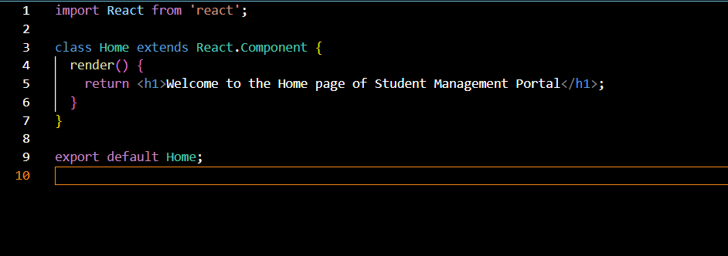

- Under Src folder add another file named “About.js”
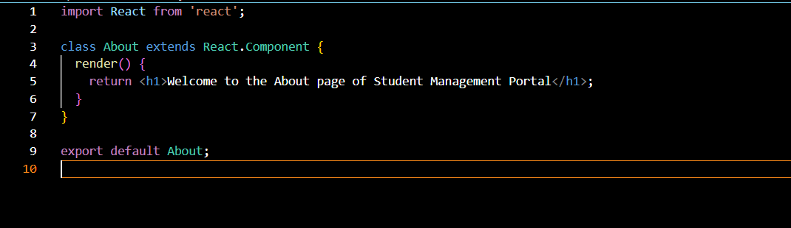

- Repeat the same steps for Creating “About” and “Contact” component by adding a new file as ”About.js”, “Contact.js” under “Src” folder and edit the code as mentioned for “Home” Component.
- Contact.js
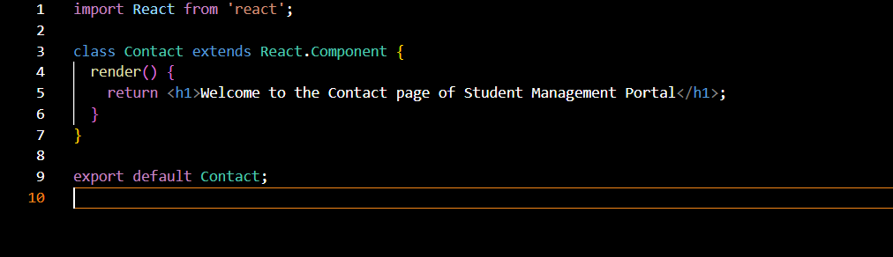

- Edited the App.js to invoke the Home, About and Contact component as follows:

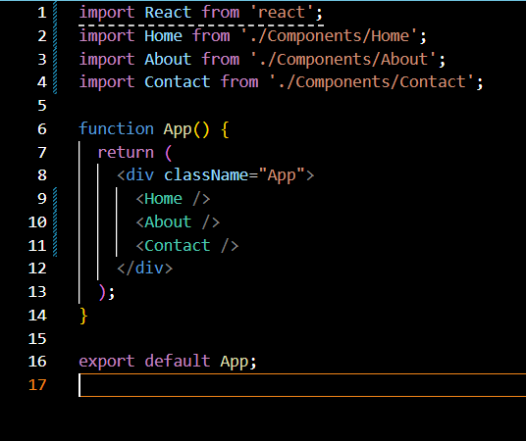

- In command Prompt, navigate into StudentApp and execute the code by typing the following command:

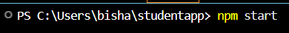
- Opened browser and typed “localhost:3000” in the address bar:

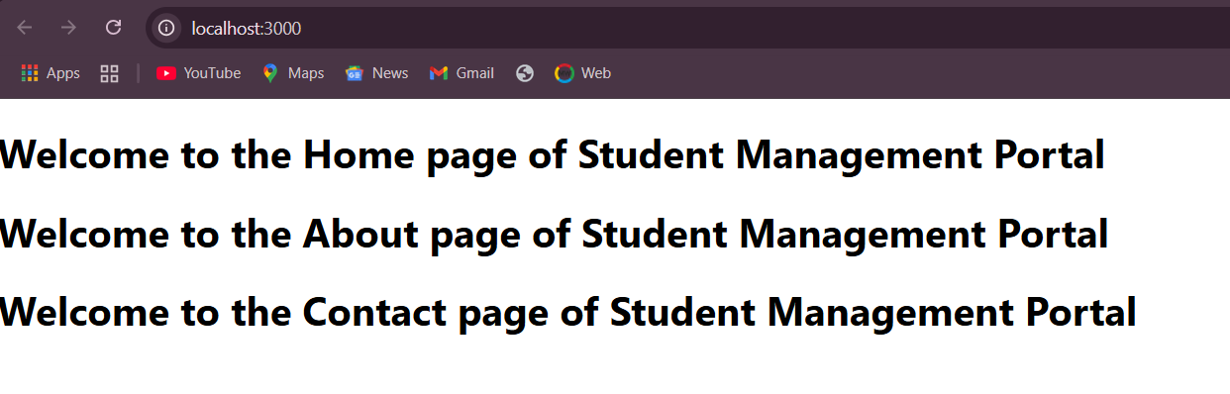
REACT-03
Objectives

- Explain React components
React components are reusable blocks of code that return JSX (HTML-like code) to define how the UI should look. They help break a big UI into smaller, manageable pieces.
- Identify the differences between components and JavaScript functions
Javascript functions perform logic or calculations and return data.
React Components return UI (JSX) and are used to build web interfaces.

- Identify the types of components
There are two types of Components:
1.Class component-uses ES6 class syntax
2.Function components-uses simple javascript functions.
- Explain class component
A class component extends React.Component, uses a render() method, and can have state and lifecycle methods.
- Explain function component
A function component is a simpler component written as a function that returns JSX.
- Define component constructor
In class components, the constructor is used to initialize state and bind methods. It’s called once when the component is created.
- Define render() function
The render() method is required in class components. It returns JSX that tells React what to display on the screen.

In this hands-on lab, you will learn how to:
- Create a function component
- Apply style to components
- Render a component
Prerequisites

The following is required to complete this hands-on lab:
- Node.js
- NPM
- Visual Studio Code

Notes

Estimated time to complete this lab: 30 minutes.
Create a react app for Student Management Portal named scorecalculatorapp and create a function component named “CalculateScore” which will accept Name, School, Total and goal in order to calculate the average score of a student and display the same.

- Create a React project named “scorecalculatorapp” type the following command in terminal of Visual studio:

- Create a new folder under Src folder with the name “Components”. Add a new file named “CalculateScore.js”

- Type the following code in CalculateScore.js

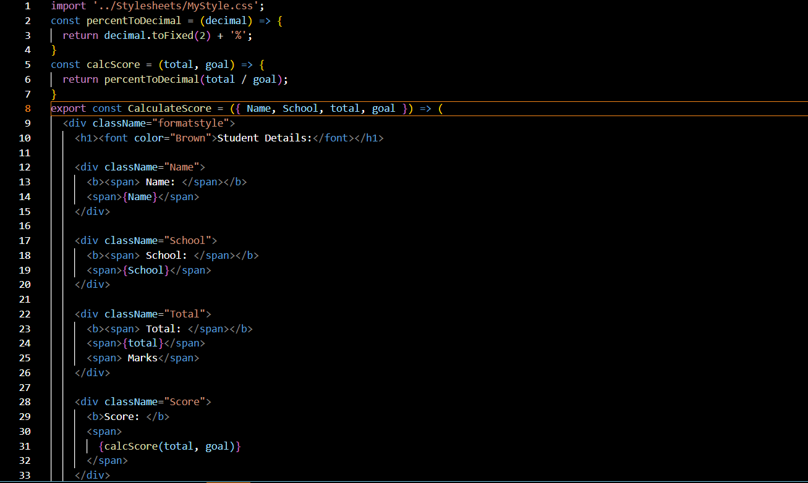

- Create a Folder named Stylesheets and add a file named “mystyle.css” in order to add some styles to the components:

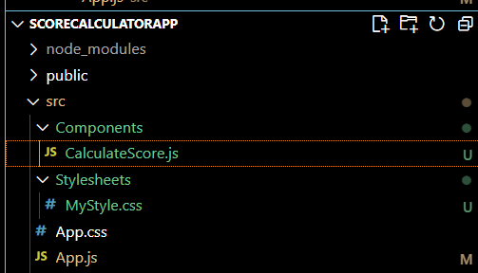

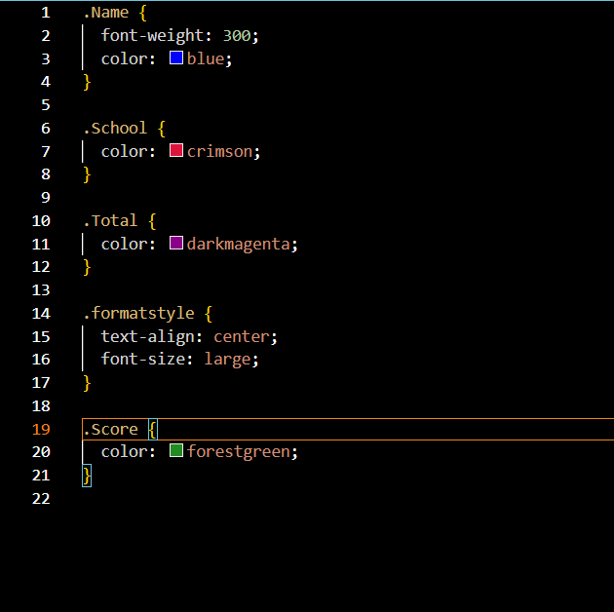

- Edit the App.js to invoke the CalculateScore functional component as follows:

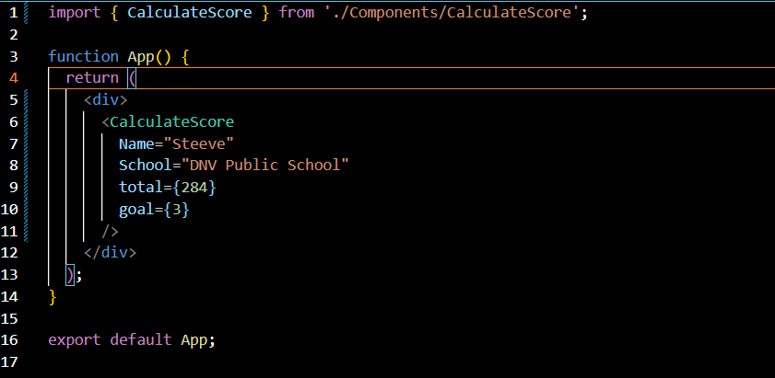

- In command Prompt, navigate into scorecalculatorapp and execute the code by typing the following command:

- Open browser and type “localhost:3000” in the address bar:

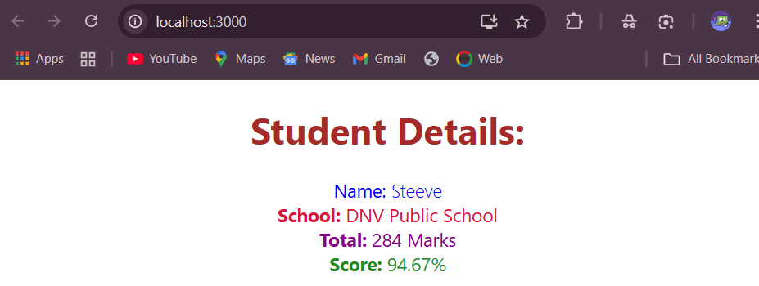

REACT-04
Objectives
- Explain the need and Benefits of component life cycle
Component lifecycle allows React to manage what happens at different stages of a component (mounting, updating, unmounting).
It helps perform tasks like fetching data, optimizing performance, and cleaning up before the component is removed.
- Identify various life cycle hook methods
For class components,the order is:
Mounting-Constructor(),getDerived StateFromProps(),render(),componentDidMount()
Updating-shouldComponentUpdate(),getSnapshotBeforeUpdate()
Unmounting-componentDidUpdate(),componentWillUnmount()
For functional components,the order is:
useEffect(),useLayoutEffect(),useRef(),useMemo(),useCallback().
- List the sequence of steps in rendering a component
Constructor(),getDerived StateFromProps(),render(),componentDidMount()

Create a new react application using create-react-app tool with the name as “blogapp”
- Open the application using VS Code
- Create a new file named as Post.js in src folder with following properties

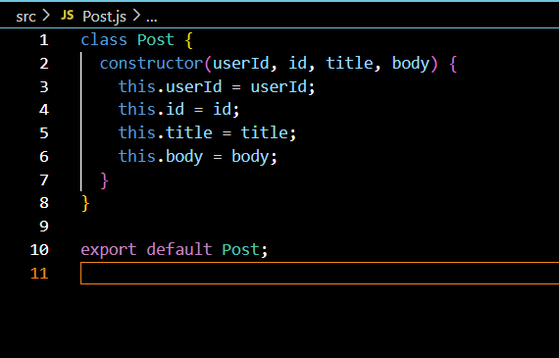
Figure 2: Post class
- Create a new class based component named as Posts inside Posts.js file
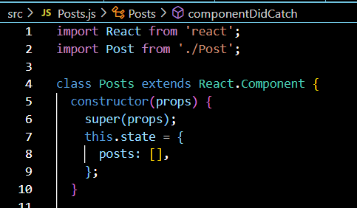
Figure 3: Posts Component
- Initialize the component with a list of Post in state of the component using the constructor
- Create a new method in component with the name as loadPosts() which will be responsible for using Fetch API and assign it to the component state created earlier. To get the posts use the url (https://jsonplaceholder.typicode.com/posts)

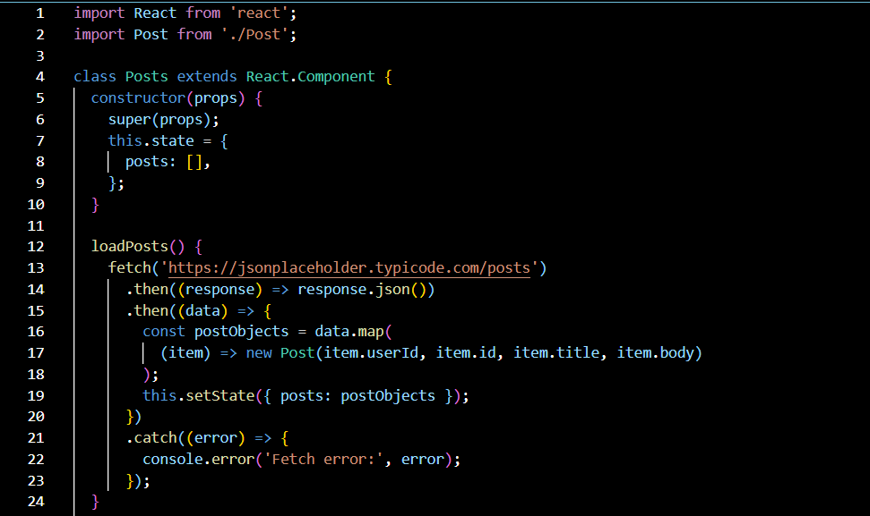
Figure 4: loadPosts() method
- Implement the componentDidMount() hook to make calls to loadPosts() which will fetch the posts

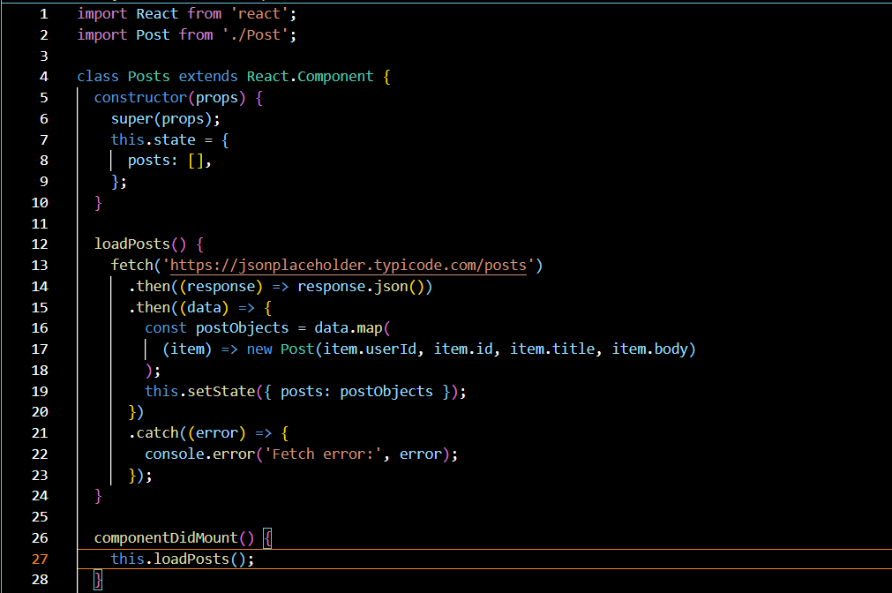
Figure 5: componentDidMount() hook
- Implement the render() which will display the title and post of posts in html page using heading and paragraphs respectively.

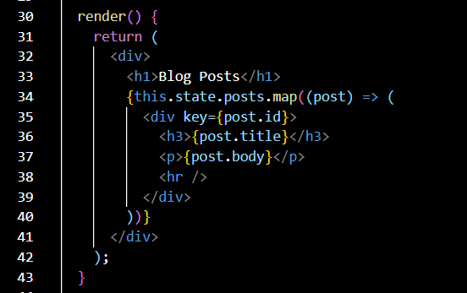
Figure 6: render() method
- Define a componentDidCatch() method which will be responsible for displaying any error happing in the component as alert messages.

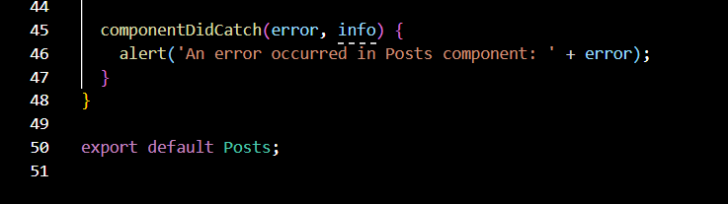
Figure 7: componentDidCatch() hook
- Add the Posts component to App component.
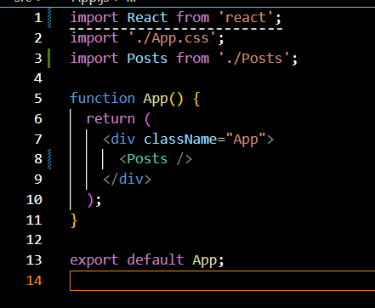
- Build and Run the application using npm start command.
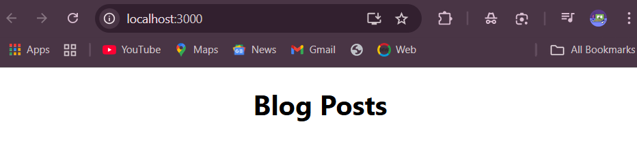

REACT-05
Objectives
- Understanding the need for styling react component
- Working with CSS Module and inline styles

My Academy team at Cognizant want to create a dashboard containing the details of ongoing and completed cohorts. A react application is created which displays the detail of the cohorts using react component. You are assigned the task of styling these react components.
Download and build the attached react application.
- Unzip the react application in a folder
- Open command prompt and switch to the react application folder
- Restore the node packages using the following commands
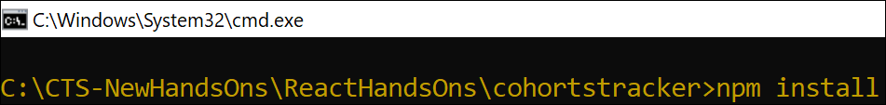
Figure 1: Restore packages
- Open the application using VS Code
- Create a new CSS Module in a file called “CohortDetails.module.css”
- Define a css class with the name as “box” with following properties
Width = 300px;
Display = inline block;
Overall 10px margin
Top and bottom padding as 10px
Left and right padding as 20px
1 px border in black color
A border radius of 10px
- Define a css style for html <dt> element using tag selector. Set the font weight to 500.
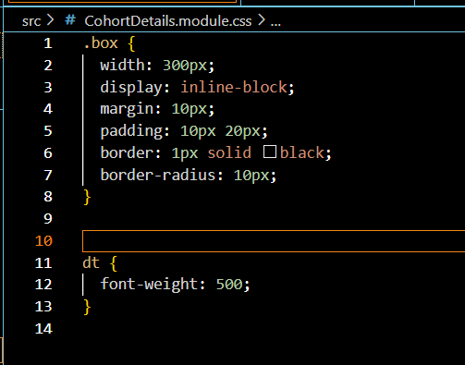
- Open the cohort details component and import the CSS Module
- Apply the box class to the container div
- Define the style for <h3> element to use “green” color font when cohort status is “ongoing” and “blue” color in all other scenarios.
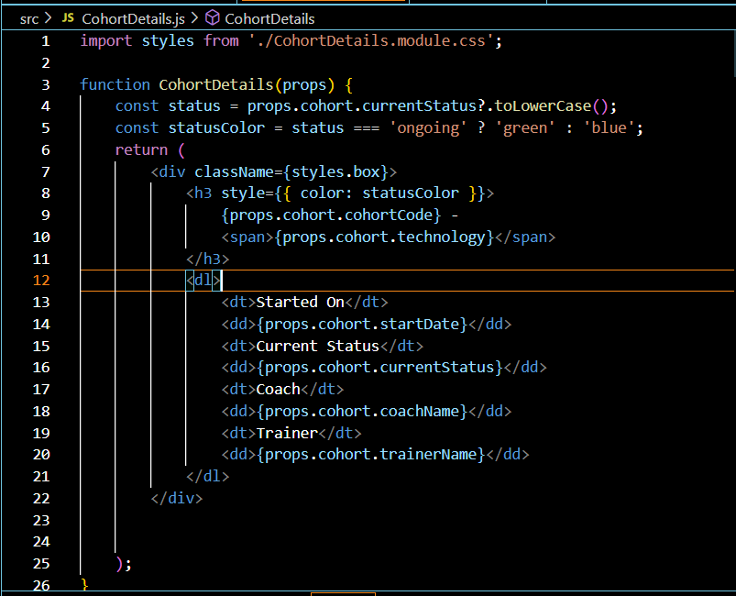
- Final result should look similar to the below image

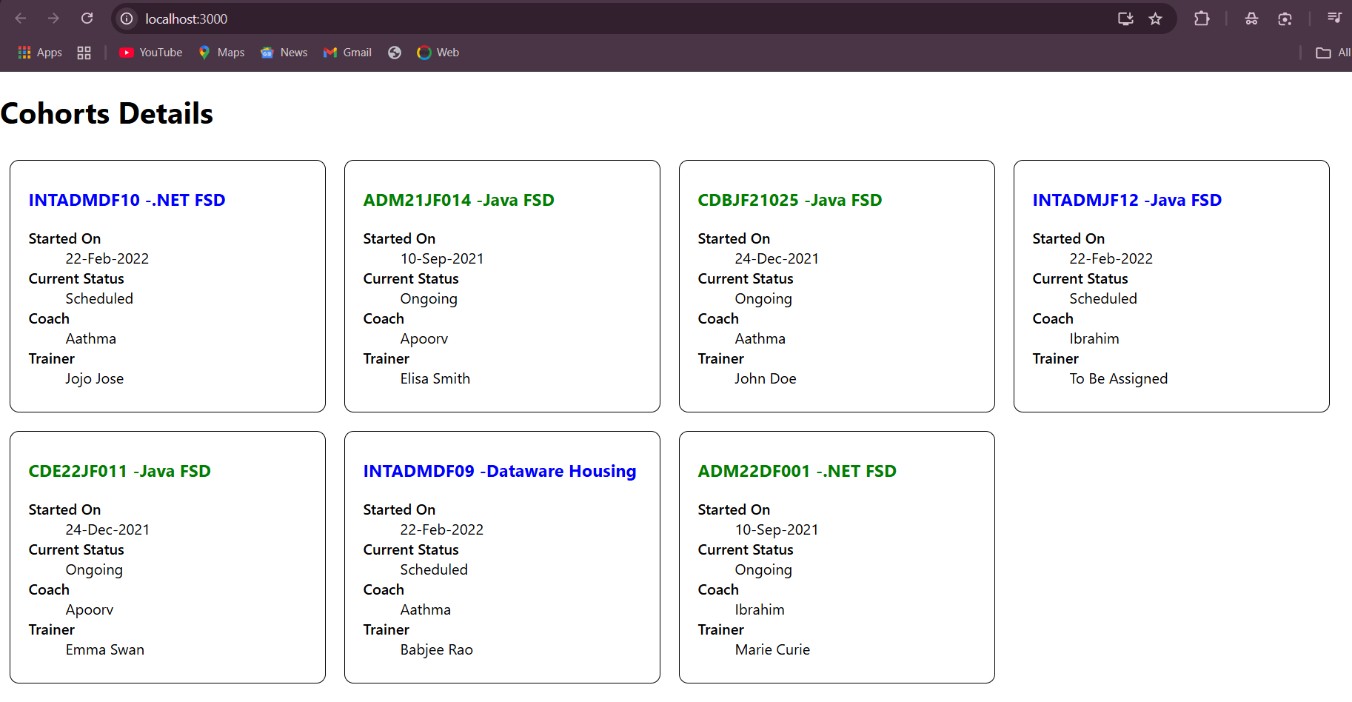
Figure 2: Final Result

